Design Document: DEMASCAS
Project Title: Decision Engineering Machine Algorithm for System Control and Action Sequencing
Lead Developer: Daksh Rathore
Version: 1.0

1. System Architecture Overview
DEMASCAS is built on a "Local-First" architecture. Unlike traditional assistants, the logic flow is strictly on-device to ensure data privacy and low latency.
- UI Layer: A lightweight interface for user interaction and feedback.
- Voice Module: Handles wake-word detection and Speech-to-Text (STT) using a quantized local engine.
- Inference Engine: A local LLM that parses natural language into JSON-formatted "Intent" packets.
- System Control Layer: The "Executor" that uses OS-level APIs (C++/Python) to open files, scrape web content, or draft emails.

2. Technical Specifications
- Language: C++ (System Logic), Python (AI/Scraping).
- AI Model: Quantized Llama-3 or Mistral (8B parameters) running via llama.cpp.
- Local DB: SQLite for encrypted storage of summaries and notes.

3. Visual Diagrams 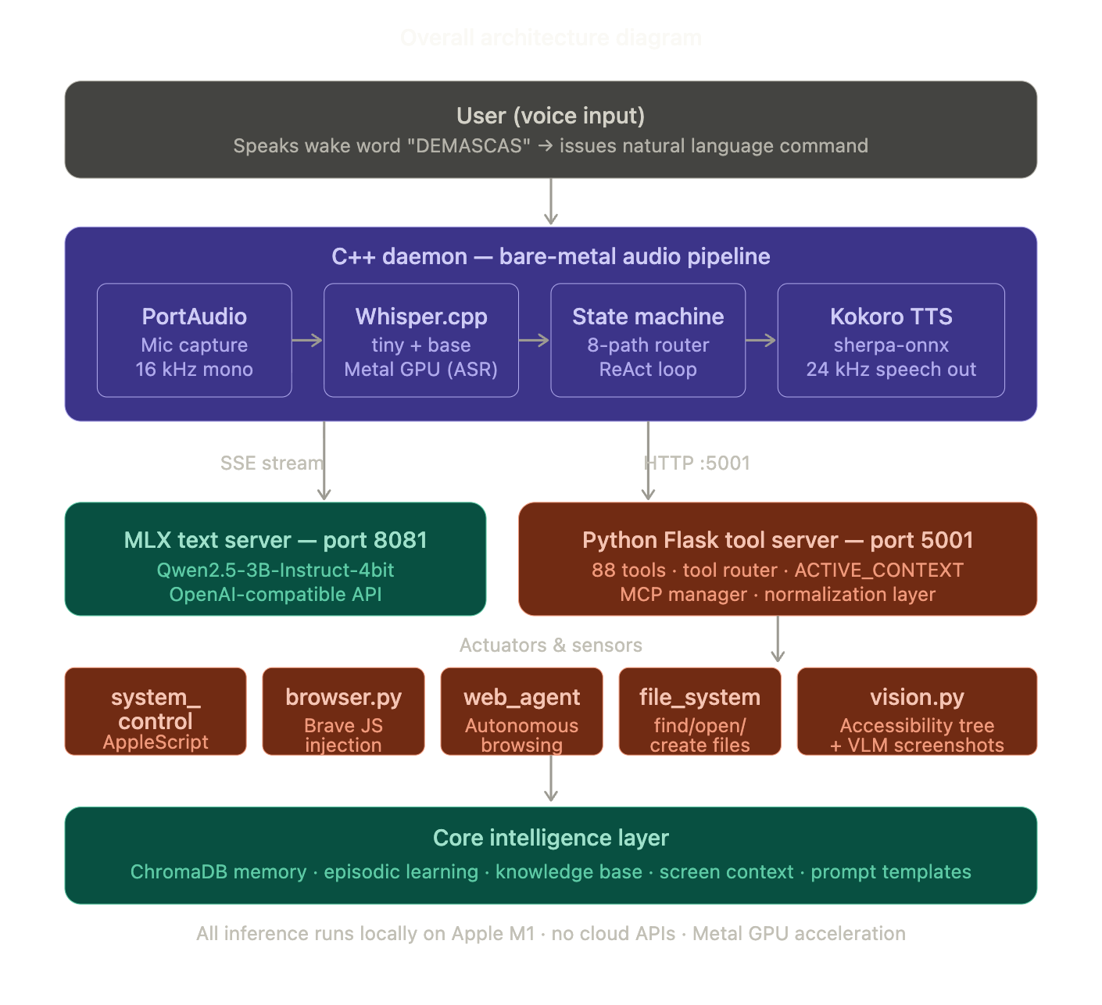

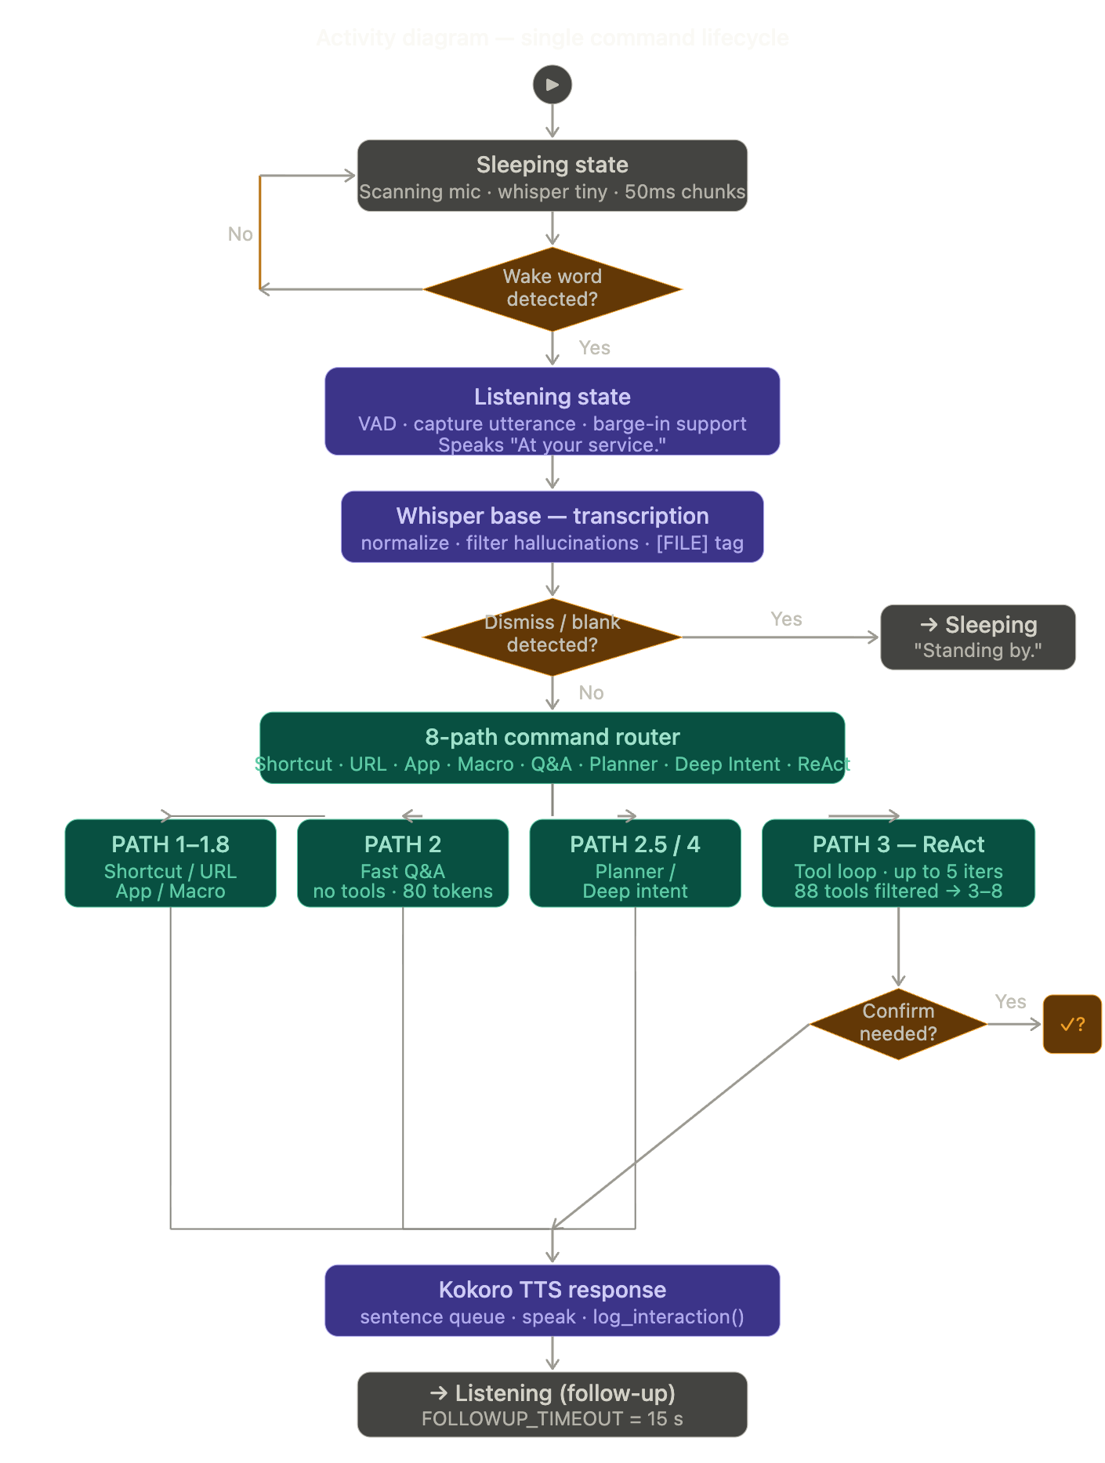
- Start Node: User says Wake Word ("DEMASCAS").
- Action: System listens for command.
- Decision Diamond: Command Recognized?
  - No: Re-trigger listener.
  - Yes: Convert Speech to Text.
- Action: AI identifies Task (e.g., "Summarize this page").
- Action: System Control Layer executes script.
- Action: Display results to User.
- End Node: System returns to idle/listening mode.

